# Testing – Pre-Testing

|  |  |  |  |  |
| --- | --- | --- | --- | --- |
| Test No. | What is being tested? | Test Data | Testing Strategy (Good, Bad, Boundary) | Expected result |
| 1 | Settings Page | Logout button  Change username option  Change password option  Change profile picture | Good  Good  Good  Good | Logout  Username change  Password change  Picture change |
| 2 | Profile Page | Display name  Display username  Display number of followers  Display number of recipes posted | Good  Good  Good  Good | Name display  Username display  Display number of followers  Display number of recipes posted |

# Test Results

# 

# standard user profile before settings:

note that is not a pro user, so he has 0 recipes published

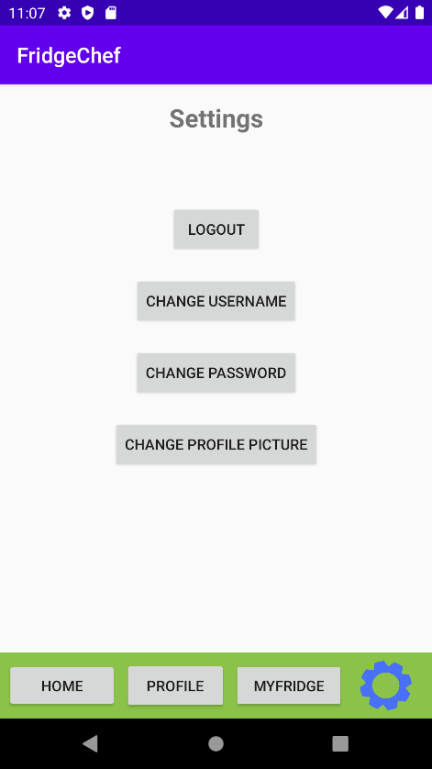 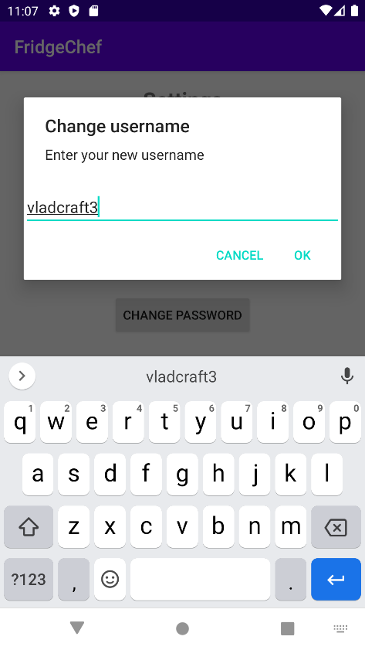

# The change username opened the username change page and the new username has been introduced

# 

# The change password button opened the password change page and the current password and a new password have been introduced in order for the password to be change. Note: the passwords above are different.

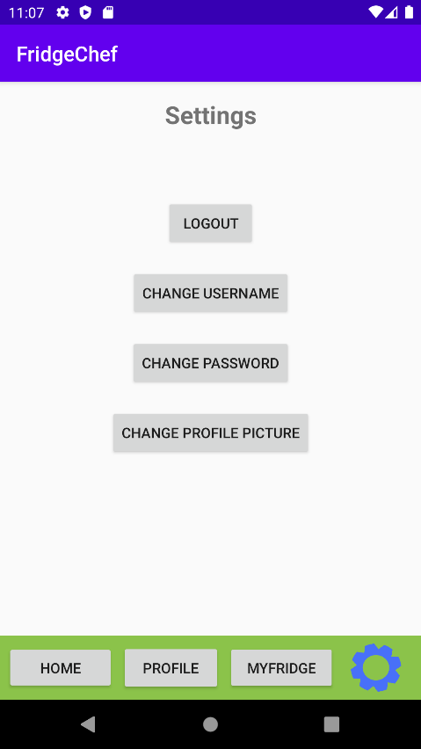 

The change profile picture opened the select photo page where the user can select uploaded photos in order to change his/her profile picture.

 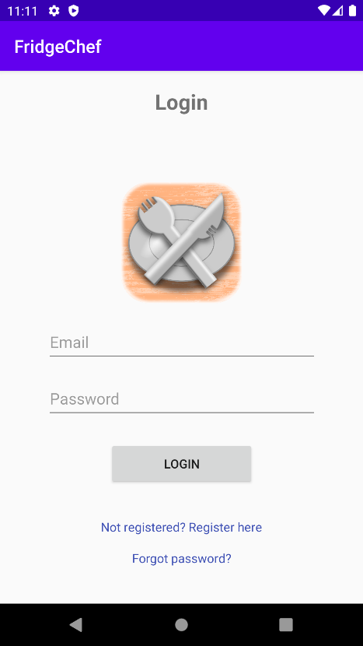

# The logout button opened the registration page, so, is working as intended.

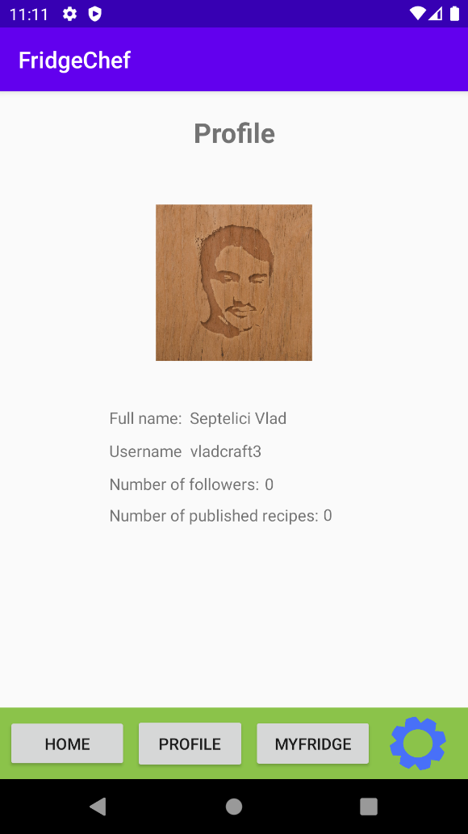

This is the new user page after the above settings have been applied. Also, the user logged in with the new password. In conclusion, the settings page is working as intended.

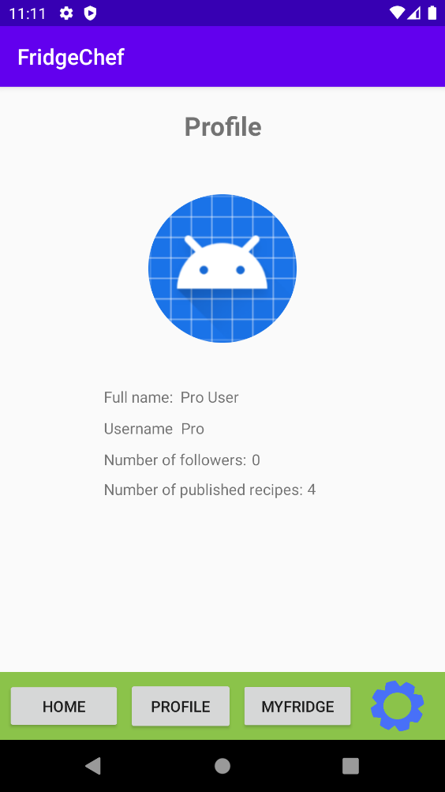

# This is a screenshot of a pro user, notice that he/she has 4 recipes published, comparing to the standard user that always has 0 recipes. As well as the standard user, the full name, username and number of followers are being displayed. In conclusion, the profile page is working as intended.

# Testing – Post-Testing

|  |  |  |  |  |  |  |
| --- | --- | --- | --- | --- | --- | --- |
| Test No. | What is being tested? | Test Data | Testing Strategy (Good, Bad, Boundary) | Expected result | Actual result | Actions needed |
| 1 | Settings Page | Logout button  Change username option  Change password option  Change profile picture | Good  Good  Good  Good  Good | Logout  Username change  Password change  Picture change | Went to login page  Username change  Password change  Picture change | Press the button  Press button  Enter new username  Press button  Enter new password  Press button  Select new picture |
| 2 | Profile Page | Display name  Display username  Display number of followers  Display number of recipes posted | Good  Good  Good  Good | Name display  Username display  Display number of followers  Display number of recipes posted | Name display  Username display  Display number of followers  Display number of recipes posted | Just press the profile button and everything will be displayed on the profile page |